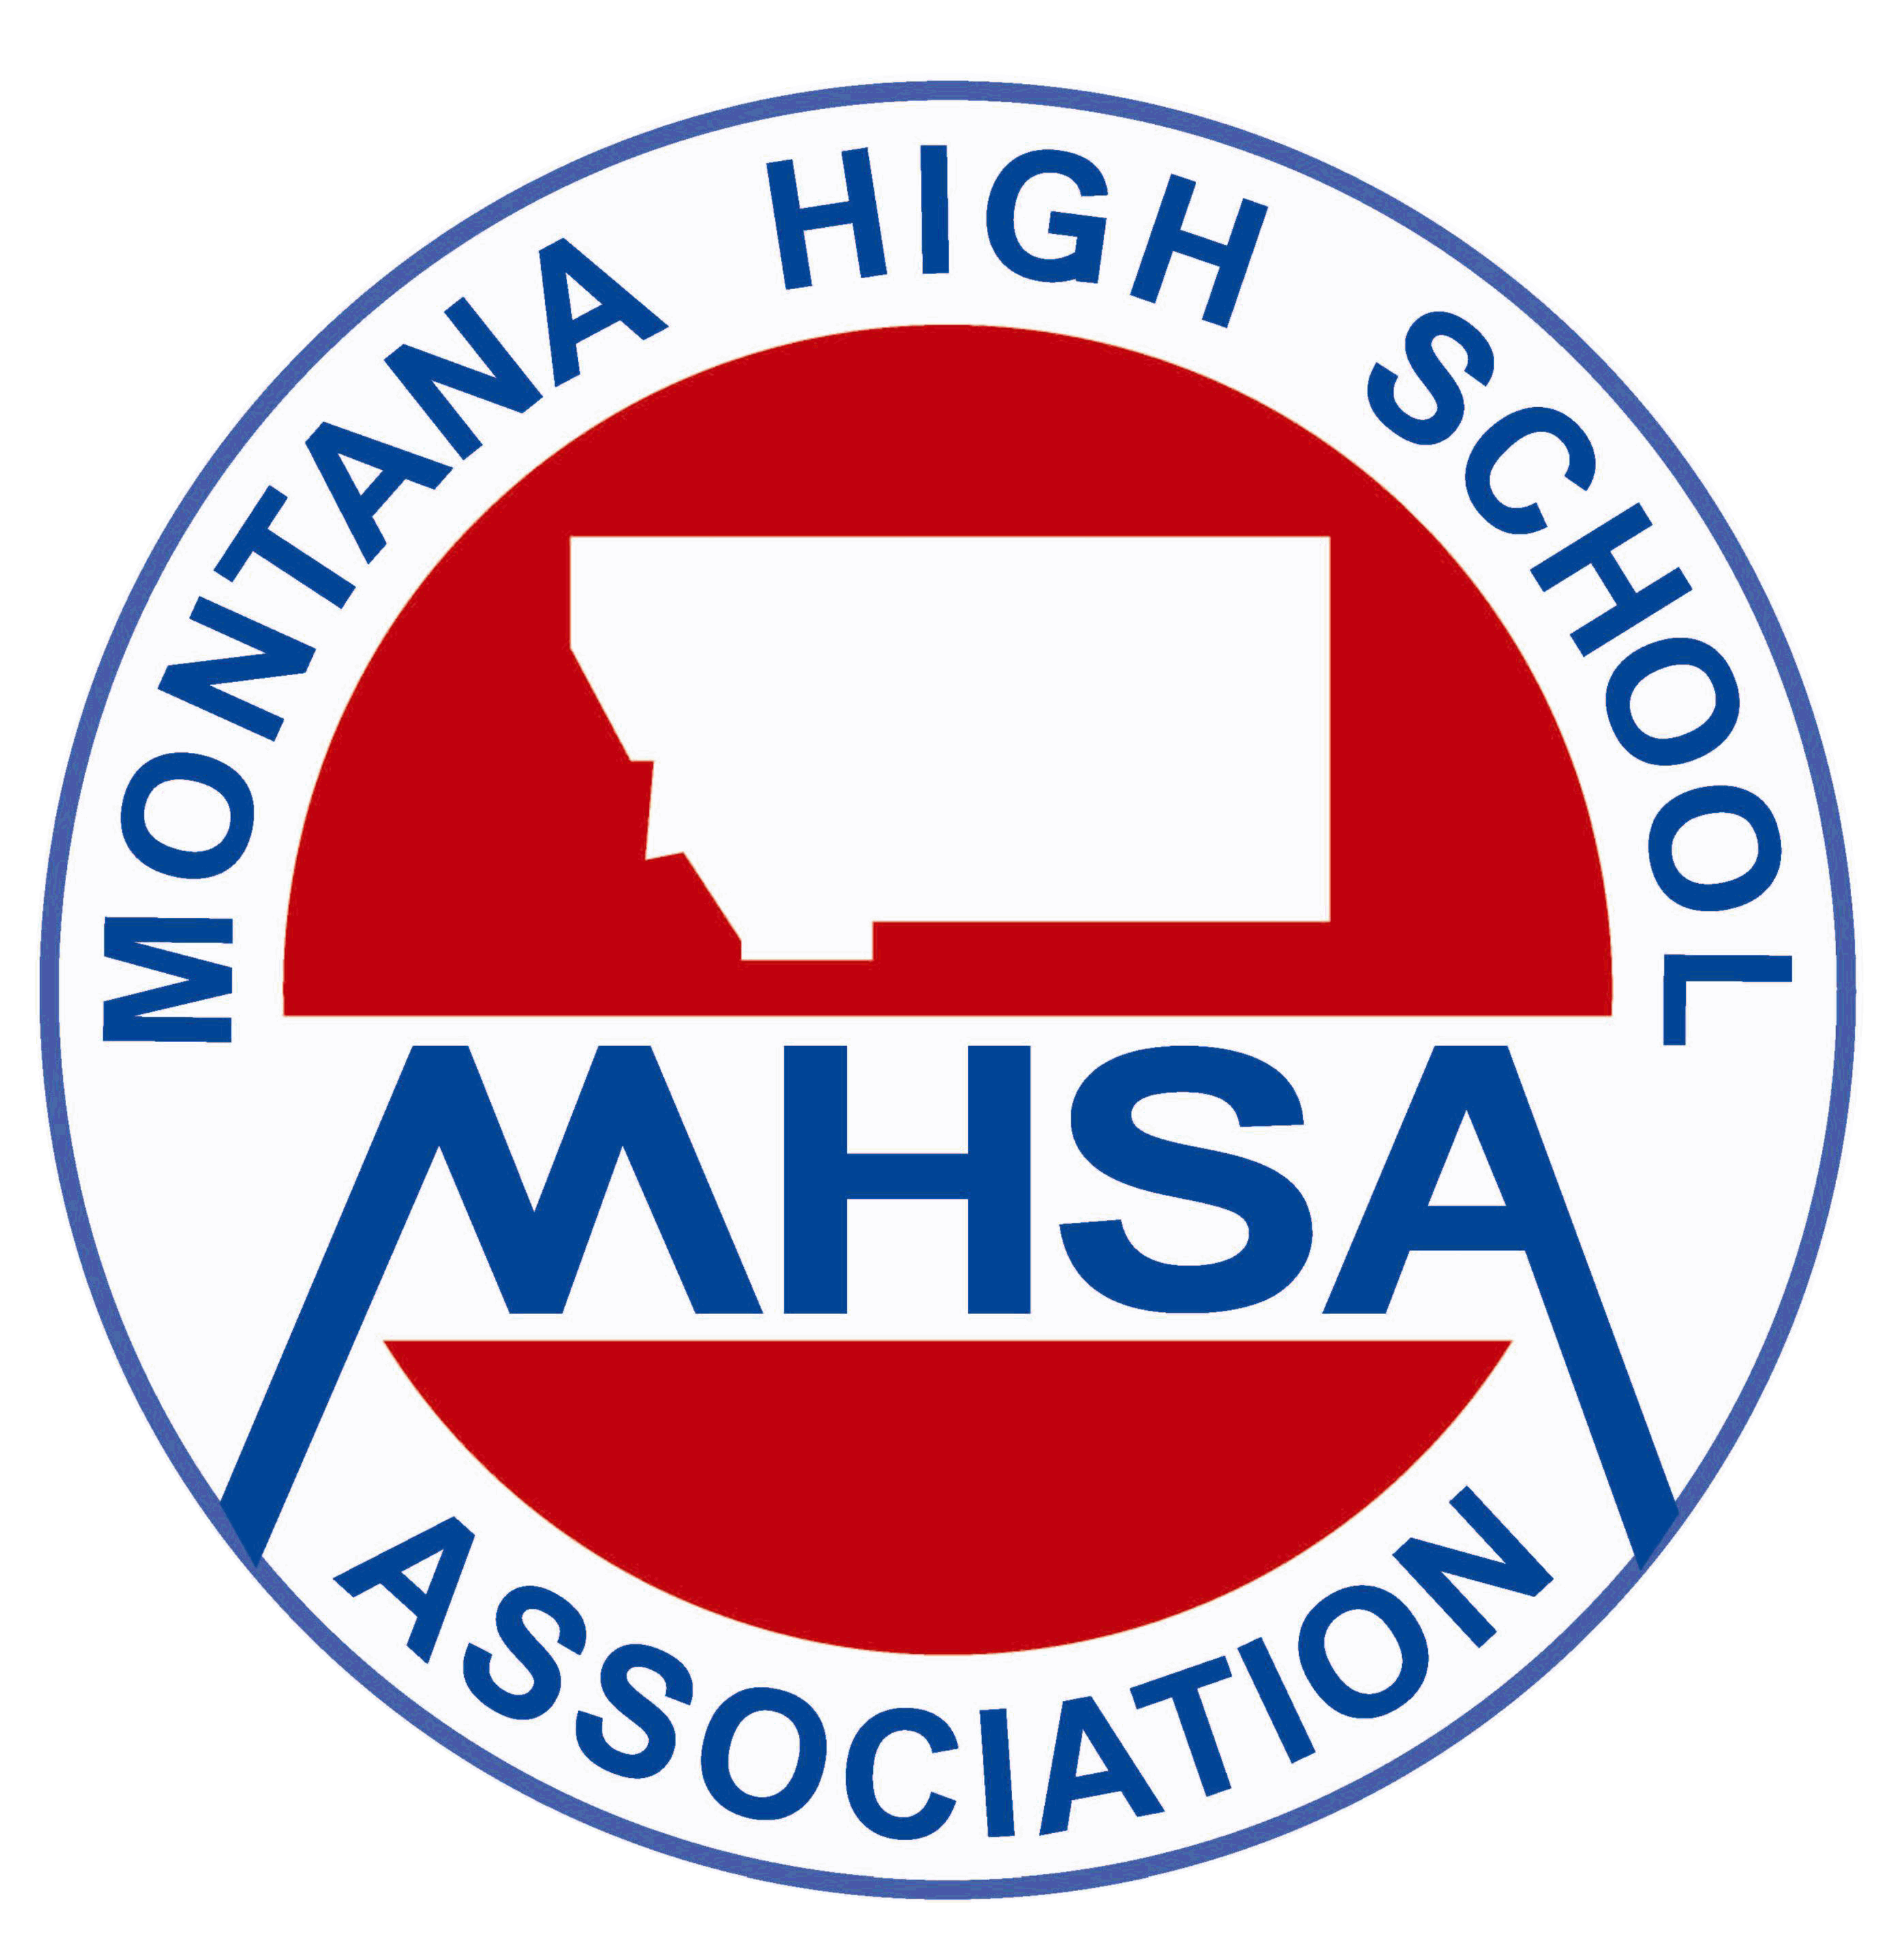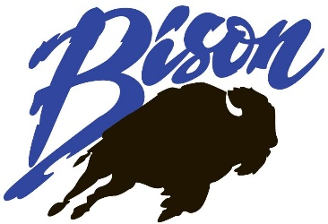

AA Coaches,
On behalf of CM Russell High School and Great Falls High School, we invite you to the Class AA State Speech and Debate Tournament on January 26-27, 2018 at C.M. Russell High School in Great Falls, Montana.
If you have questions about the tournament, please contact tournament director Steven Hurin at steven_hurin@gfps.k12.mt.us or (406) 788-8928.

Entry Deadline: Initial online registration is due Wednesday January 17th by 4:00 PM. Final registration and changes to the state book are due by 8:00 AM, Monday, January 22nd to allow time for printing. Register online at forensicstournament.net. Changes after the website closes must be made via email to steven_hurin@gfps.k12.mt.us. Tabbing assignments will be sent via email. School codes will be given when you register in the tab room at the CMR Media Center. Timely registration is appreciated in order to guarantee the correct number of judges and that all materials for State are ready for your arrival.

Entry Limit: Per the handbook, entries per event are limited to four with a maximum team limit of 42.

Fees: Each school will be assessed an entry fee of $35 and each participant will be charged a $5.00 fee per the state tournament managers’ bulletin.

Locations: All events will be held at C.M. Russell High School. Please know that there will be construction in the parking lots and we will be sending advice for parking as the tournament comes closer with a construction update. However, construction should not affect the tournament as there is no construction going on inside of the building.

Concessions: Information on concessions is forthcoming.

Awards: Awards will be held in Bill Will Hall. Music will be provided for students prior to coaches entering the auditorium by the Russ Tones Jazz band directed by Mr. Chris Kloker before awards. Awards will begin once finals are tabulated and certificates are printed.

Debate Topics:
Legislative Debate – Domestic: Criminal Justice Reform, Foreign: Korean Peninsula
Public Forum Debate – Resolved: Spain should grant Catalonia its independence.
Lincoln Douglas Debate - Resolved: Plea bargaining ought to be abolished in the United States criminal justice system.
Policy Debate - Resolved: The United States federal government should substantially increase its funding and/or regulation of elementary and/or secondary education in the United States.

Tournament Schedule: All events will be held at C.M. Russell High School.

Friday, January 26th:
Speech
4:00 PM 6:00 PM 8:00 PM
*Extemp Draw at 3:30PM in room 307.

Debate
4:00 PM 6:00 PM 8:00 PM

Saturday, January 27th:
Speech
8:30 AM 10:30 AM Semifinals 1:00 PM Finals 3:00 PM
*Extemp Draw at 8AM in room 307.

Debate
8:00 AM 10:00 AM Octofinals 12:00 PM Quarterfinals 2:00 PM Semifinals 4:00 PM

Finals 5:30 PM

